Operation Manual of Trim-off SK6368 PDT

Hardware:
Computer(x86) x1,
USB3.0 cable with micro B plug x1,
Skymedi Switch PCBA (SATA to USB3.0) x1,
Generic MSATA change to SATA PCBA x1,

Software:
Operation system: Windows xp sp3 (necessary condition)
Skmedi PDT program(V4629 trim off)

Operation steps:
- Plug USB3.0 cable with two switch PCBAs into computer(x86) (compatible with USB2.0), then boot the computer.

- Program path: C:\v4629_TrimOff_20140505\tools\SKPdt.exe (Program must be placed in root of C: because of path setting) .
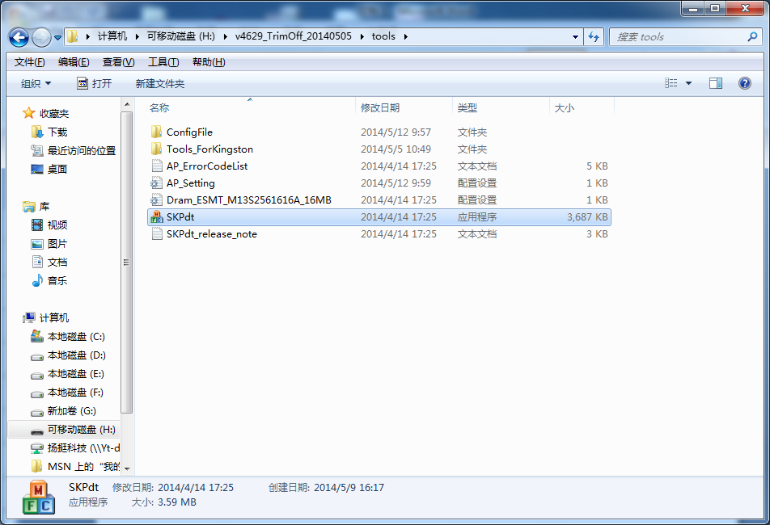

- Turn on the switch on the mSATA to USB PCBA, then open this program.
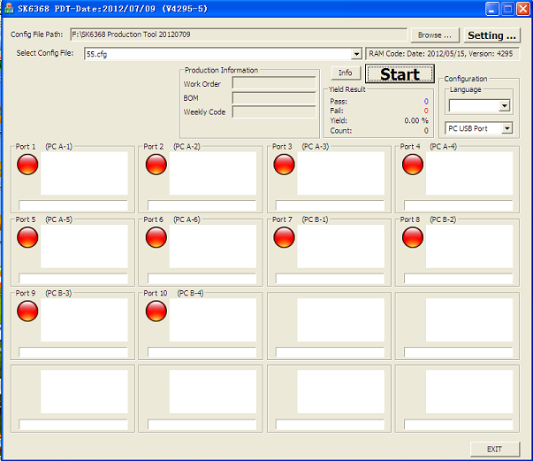

- Press button “Setting”, you can change model no and serial no as below picture. After completing the setting, you must press the button “Save and Exit”.
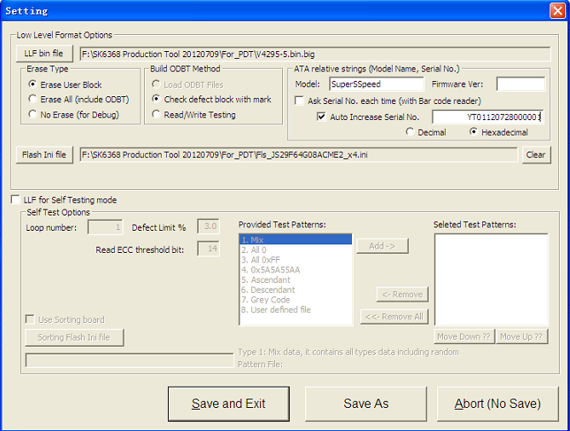

- Press the button “Start”, you can see the process like below. If appear 100%, mSATA SSD has been successfully finished. After turning off the switch, you can unplug the switch PCBA(MSATA to SATA), change mSATA SSD, then repeat the same steps.
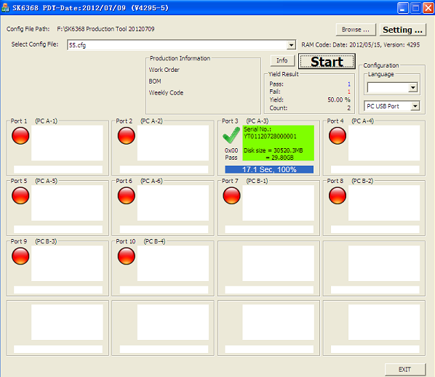

- You can use CrystalDiskInfo to check its Trim function and health status.
